

🕯Tuff '~' Central🕯
Text Channels / 👆mod-general

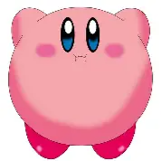

Mariobye 👋 5/25/2026 3:37 PM
this is mod channel but ill mainly talk about the 5 second challenge list we ar eamking

3:37 PM

actually

3:37 PM

this is normal



jambled_ 5/25/2026 6:14 PM
what is that

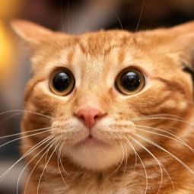

cat :3 5/25/2026 6:15 PM
scroll down below the gdps

jambled_ 5/26/2026 12:01 AM
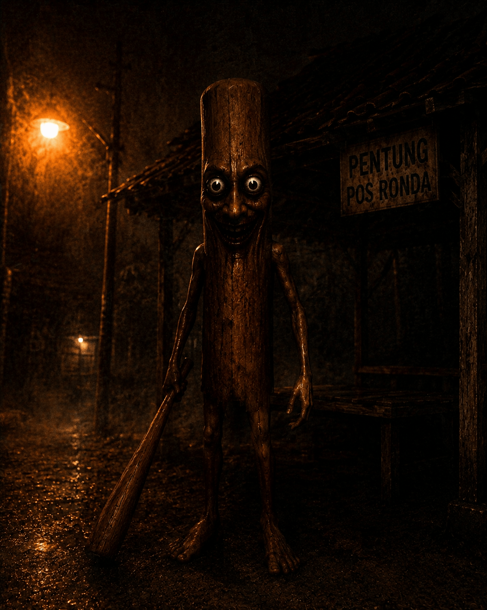

12:01 AM

evil tung

Mariobye 👋 6/1/2026 5:10 PM
@💎Co-Chudner💎 @✨Chudmin✨ 2 things for you guys! 1. Do we add emoji's to every role (for design purposes) 2. Do we have mod apps and attempt to get about 2 more Chudmins.

cat :3 6/1/2026 5:10 PM
yes, yes

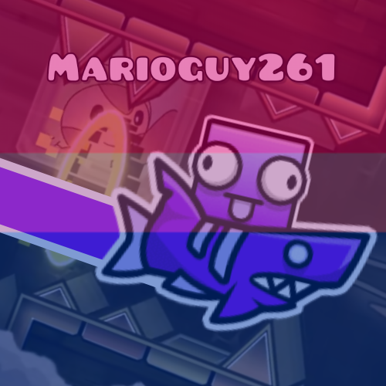

Mariobi261 6/1/2026 5:10 PM

answers

1
3 votes 50%

2
3 votes 50%
6 votes Multiple answers allowed Poll closed

Mariobye 👋 6/1/2026 5:11 PM
ok perfect

5:11 PM

could someone make good application

5:12 PM

the problem is aswell is I feel like someone should be demoted, but everyones done stuff, I have no idea its just a thought but discussing it would be nice

5:12 PM

so please consider

cat :3 6/1/2026 5:12 PM
ill make the app

1

5:13 PM

hold up

Mariobye 👋 6/1/2026 5:13 PM
awesome

cat :3 6/1/2026 5:20 PM
can i put one of the questions as "are you a geometry dasher" as a joke @Mariobye 👋

5:21 PM

its not gonna be required in the form btw

Mariobye 👋 6/1/2026 5:21 PM
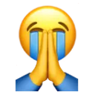

cat :3 6/1/2026 5:22 PM
https://docs.google.com/forms/d/e/1FAIpQLSfpZa0g5KkoVZIqotL6TYv0C7LHZMj8iyvoj0Fm0nTh-0NJtg/viewform

Job application form

Lorem ipsum dolor sit amet, consectetur adipiscing elit. Curabitur quis sem odio. Sed commodo vestibulum leo, sit amet tempus odio consectetur in. Mauris dolor elit, dignissim mollis feugiat maximus, faucibus et eros.
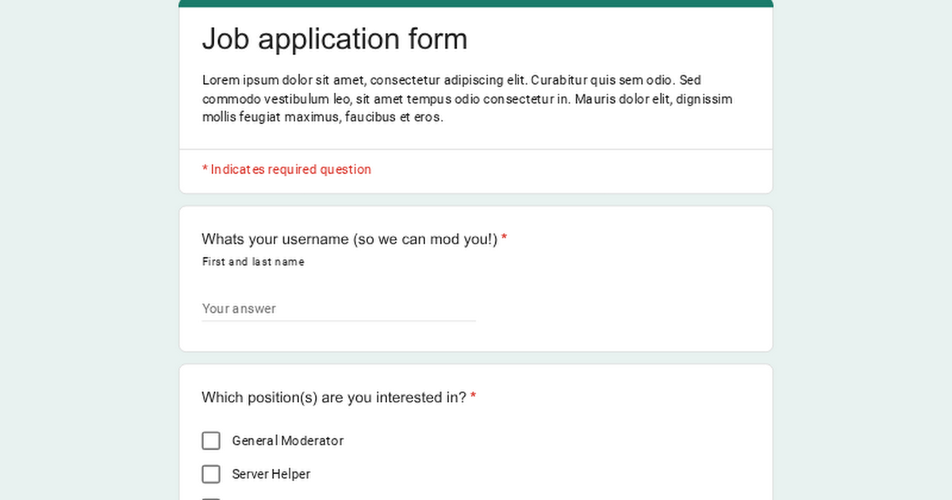

5:22 PM

alright its done!

Mariobye 👋 6/1/2026 5:23 PM
Awesome Sauce

5:23 PM

now

5:23 PM

can we talk

5:23 PM

about

Mariobye 👋
the problem is aswell is I feel like someone should be demoted, but everyones done stuff, I have no idea its just a thought but discussing it would be nice
Mariobye 👋 6/1/2026 5:24 PM
this!!

5:24 PM

marioguy you too

5:24 PM

:D

cat :3 6/1/2026 5:27 PM
we should prob wait time for demotes

5:27 PM

im not sure if jambled is that active but i think hes active so no demote btw

Mariobye 👋 6/1/2026 5:30 PM
yeah

5:30 PM

thats what im getting at

5:30 PM

If jambled doesnt become more active or atleast give a reason then he is #1 for demotion

5:30 PM

because you 2 are active everyday so far

jambled_ 6/1/2026 8:22 PM
listen bud

8:22 PM

i am going on a 3 week trip out of the country

8:22 PM

so im probably going to to be inactive

Mariobye 👋 6/1/2026 8:23 PM
ok ty for telling us

8:23 PM

you wont be demoted likely

8:23 PM

so ty

jambled_ 6/1/2026 8:23 PM
your welcome mur shark

8:23 PM

Mariobye 👋 6/2/2026 2:26 PM
@cat :3 why does the application ask for email and phone number

2:26 PM

Like gng

2:27 PM

And also there is not a vc mod brotherine

cat :3 6/2/2026 3:20 PM
ohh i used a template i forgot lmaooo

1

3:21 PM

alr it should be fixed @Mariobye 👋

Mariobye 👋 6/2/2026 4:18 PM
Bro

4:18 PM

What is vc mod

4:19 PM

The only mod there is, is admin bro

4:19 PM

And we need more questions

cat :3 6/2/2026 4:51 PM
Vc mod is ppl who moderate vc

4:52 PM

Incase someone says smth bad in vc lowk

4:52 PM

Also I will add more questions im js not home rn @Mariobye 👋

cat :3
Vc mod is ppl who moderate vc
Mariobye 👋 6/2/2026 5:03 PM
But that could literally just be a normal mod who is in vc

cat :3 6/2/2026 5:04 PM
Alr I'll remove it when I get home ig

Mariobi261 's poll answers has closed. 6/2/2026 5:10 PM

Poll closed
6 votes
View Poll

Mariobi261 6/2/2026 5:11 PM
ok do both

cat :3 6/2/2026 6:22 PM
@Mariobye 👋 i fixed the mod apps and add some more questions

1

Mariobye 👋 6/2/2026 6:23 PM
guess what

6:23 PM

post it in announcements

cat :3 6/2/2026 7:31 PM
mod apps so far btw top answer is sevant bottom is kiresev

7:32 PM

for the answers idk its confusing

Mariobye 👋 6/2/2026 7:33 PM

7:38 PM

@💎Co-Chudner💎 @✨Chudmin✨ Do we add levels bot and roles which give specials perms the higher up. Ex: 20+ is advertising, 10+ is media channel because people are wierd. Give me a simple Yes or No

3

Mariobi261 6/2/2026 7:39 PM
yes

Mariobye 👋 6/2/2026 7:39 PM
should we ask the community in #📊-polls

cat :3 6/2/2026 7:48 PM

7:49 PM

btw 3rd is idk

7:49 PM

@Mariobye 👋

7:50 PM

cat :3 6/2/2026 8:27 PM

cat :3 6/6/2026 9:22 PM

cat :3 6/12/2026 10:15 PM
@Markiplier now you have better mod general

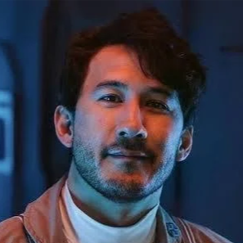

cat :3
@Markiplier now you have better mod general
Markiplier 6/12/2026 10:16 PM
thank you ping4send

10:17 PM

cat :3 6/12/2026 10:17 PM
np :3



myfyy 6/13/2026 12:56 AM

Mariobye 👋 6/13/2026 12:56 AM

12:56 AM

sh 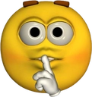

jambled_ 6/24/2026 12:04 AM



LpopOff 7/2/2026 9:48 PM
idk at this point

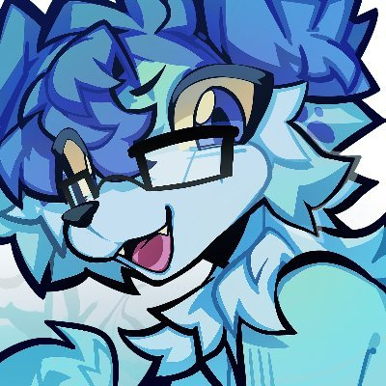

Mariobeye261 7/20/2026 11:43 PM
Yo

Mariobye 👋 7/20/2026 11:45 PM


jambled_ 7/20/2026 11:59 PM

Mariobye 👋 8/25/2026 9:01 PM
@✨Chudmin✨ @🌟Trial Mod🌟 and Wiyn

9:01 PM

we need to discuss smth

9:01 PM

We need to discuss if GoofiBoy should be unbanned

Mariobeye261 8/25/2026 9:01 PM
Huh

9:01 PM

He's banned?

Mariobye 👋 8/25/2026 9:01 PM
yeah

jambled_ 8/25/2026 9:01 PM
yeah

Mariobye 👋 8/25/2026 9:01 PM
hes been banned

9:01 PM

for a long time

jambled_ 8/25/2026 9:01 PM
he said n word many times

9:02 PM

so he got banned

Mariobye 👋 8/25/2026 9:02 PM
he said there is no reason for him to be banned anymore

Mariobeye261 8/25/2026 9:02 PM
How long has it been exactly?

Mariobye 👋 8/25/2026 9:02 PM
idk

jambled_ 8/25/2026 9:03 PM
july/june

Mariobye 👋 8/25/2026 9:03 PM
he says that he is 13 so he should be unbanned since he is above TOS requirements

Mariobeye261 8/25/2026 9:03 PM
Wait was that why he was banned

jambled_ 8/25/2026 9:03 PM
that isnt the only reason hes banned tho

Mariobye 👋 8/25/2026 9:03 PM
and that if he got banned for being underage then other people (marioguy etc) shouldve been banned

jambled_ 8/25/2026 9:03 PM
thats the thing

Mariobye 👋 8/25/2026 9:03 PM
so its unfair

9:04 PM

to him

Mariobeye261 8/25/2026 9:04 PM
Ig unban him

9:04 PM

If he isn't underage anymore, and it's been a while, then ig he should be able to come back

myfyy 8/25/2026 9:05 PM
hi

Mariobye 👋 8/25/2026 9:06 PM
should we wait for Wiyns statement

jambled_ 8/25/2026 9:07 PM
@💎Co-Chudner💎

9:07 PM

wiyn wiyn wiyn



wiynlol 8/25/2026 9:07 PM
Bro

9:07 PM

What

jambled_ 8/25/2026 9:08 PM
they are making a discussion

9:08 PM

we need ur input

wiynlol 8/25/2026 9:08 PM
About

jambled_ 8/25/2026 9:08 PM
goofyboi

wiynlol 8/25/2026 9:08 PM
Keep him banned

jambled_ 8/25/2026 9:08 PM
@👑MurChud👑

wiynlol 8/25/2026 9:09 PM
He stated the n word multiple times, threatened to hurt himself multiple times over his initial ban, and was actively making sexual jokes to multiple members while he was 12 years old

9:09 PM

Those are my reasons

9:09 PM

Permaban

jambled_ 8/25/2026 9:10 PM
they are saying that bc hes 13 he should be unbanned

9:10 PM

like that isnt the only thing

wiynlol 8/25/2026 9:10 PM
That’s not the only reason

jambled_
like that isnt the only thing
wiynlol 8/25/2026 9:10 PM
Exactly

jambled_ 8/25/2026 9:10 PM
exactly

Mariobeye261 8/25/2026 9:11 PM
I didn't know he did all that

9:11 PM

Nvm ig

Mariobye 👋 8/25/2026 9:12 PM

unban

yes
0 votes 0%

no
2 votes 100%
2 votes Poll closed

wiynlol 8/25/2026 9:12 PM
should be all no’s btw

9:12 PM

if not that’s just disappointing

Mariobye 👋 8/25/2026 9:13 PM
bro

9:13 PM

its just a poll

wiynlol 8/25/2026 9:13 PM

jambled_ 8/25/2026 9:13 PM

9:15 PM

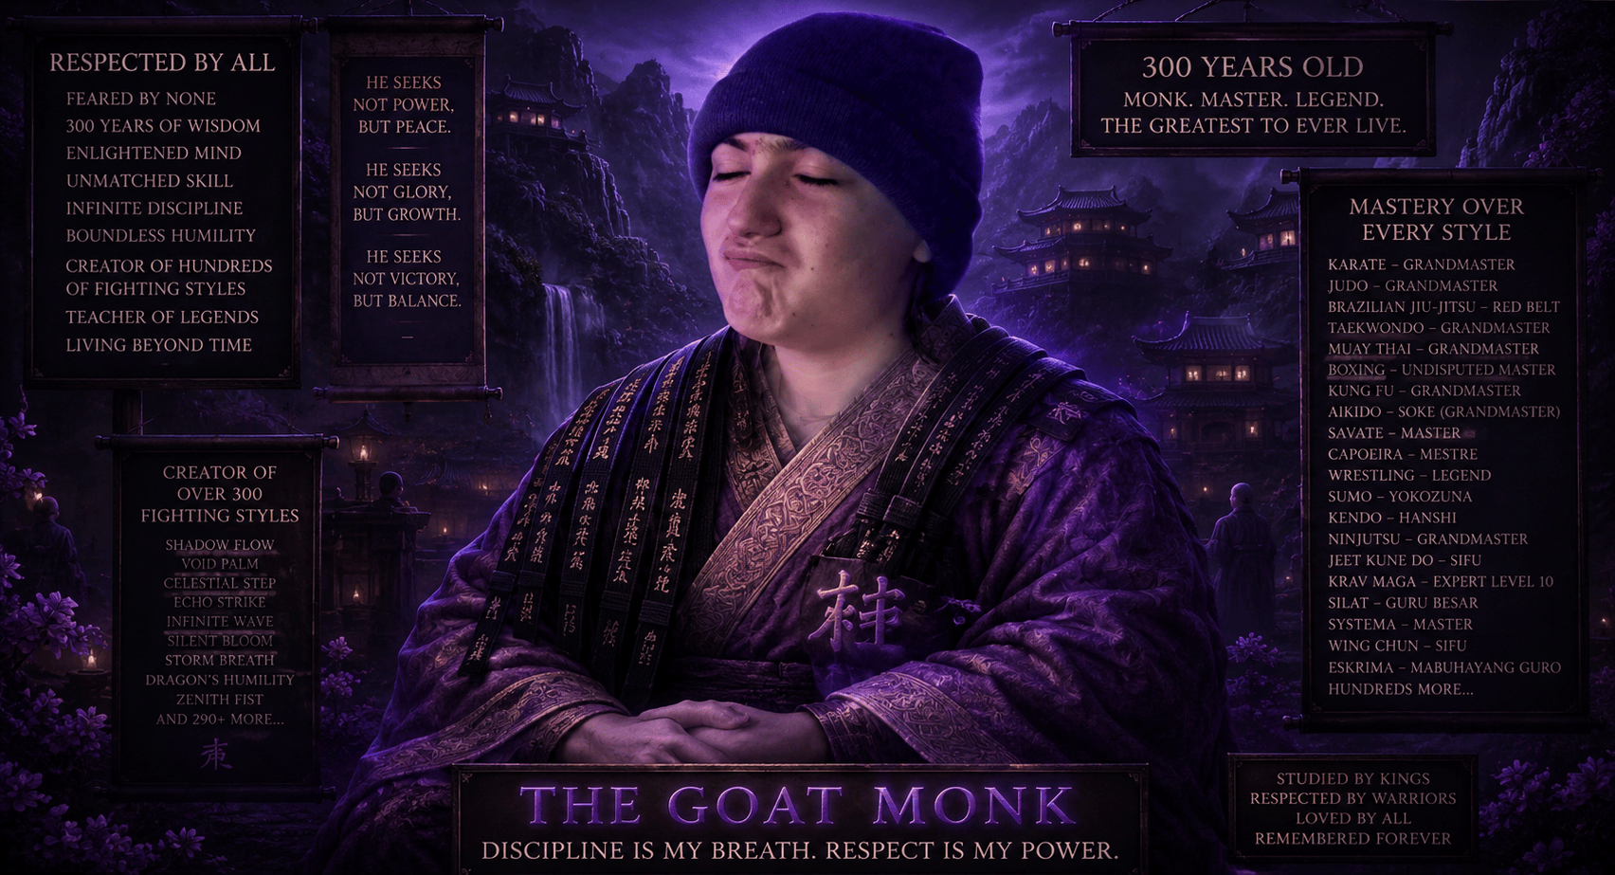

Mariobye 👋 8/25/2026 9:18 PM

Forwarded
He stated the n word multiple times: soundalikes, im tired of them making it sound like im rascist. wasnt a line or someone in the call that was black anyways?? i vivdly remeber line playing into the joke. threatened to hurt himself multiple times over his initial ban: god forbid someone is mentally ill, also im better at "suppressing" it now or putting it elsewhere and was actively making sexual jokes to multiple members while he was 12 years old: only good point but still not a valid ban. especially since it was like atleast 3 months ago.
Originally sent: 8/25/2026 9:17 PM

9:18 PM

Forwarded
i didnt say THE n word i said "the gurn" such and such
Originally sent: 8/25/2026 9:18 PM

Mariobye 👋 's poll unban has closed. 8/25/2026 10:12 PM

no ✓Winning answer
Winning answer • 100%
View Poll

Mariobye 👋
Click to see original message
wiynlol 8/26/2026 1:48 AM
i know that either way he isn’t getting unbanned but for the sake of him thinking it isn’t valid, I’m bringing it up. His first point states that he used a phrase that sounded like the n word, and he mentions that it wasn’t meant to hurt someone in that call who could’ve been black. That point is overall just idiotic. There should be zero reason for a person to say such a thing even if a black person isn’t in call. The fact is he said an n word soundalike, which is inherently wrong and offensive to the black community. His next point was his threats against himself by harming himself. He mentioned him being mentally ill and now being better at suppressing these urges (let’s just say that). First of all, I’m glad to hear that he’s gotten better at controlling it, but overall when it comes to a person hurting themselves because they were banned for breaking the rules (blatant racism and being under the age of 13 at the time), that isn’t an excuse to do such a thing. I know this may not be true but it felt like a defense mechanism to make people feel bad for you just so you can be let off. Of course, that may not be true and I’m not accusing him whatsoever. His last point was towards the sexual jokes. He mentioned that him making sexual jokes at the really young age of 12 is NOT a valid ban. What the fuck is he talking about. He is a 12 year old boy making sexual comments towards those older than him. It doesn’t matter whether he is almost 13 years old. He is still making weird comments and jokes. There is ZERO absolute reasoning to make these jokes. Stating that it was 3 months ago wouldn’t solve this issue either, nor would the fact that he’s 13 years old now. The problem with this was that a 12 year old boy on discord was making sexual jokes towards people at least 2-3 years older than him. If it was the other way around, that would be considered grooming, that’s how weird that situation is. I want you to forward this message to him.
- wiyn

1:48 AM

sorry for the long ass message holy shit

Mariobye 👋 8/26/2026 1:50 AM
dang

Mariobye 👋 8/26/2026 6:07 PM
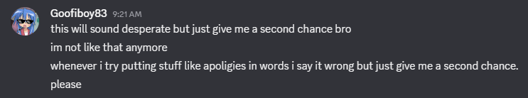

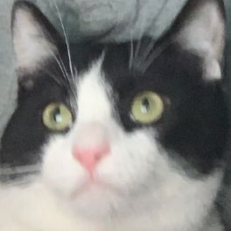

Big Hunky Daddy 9/4/2026 5:19 PM
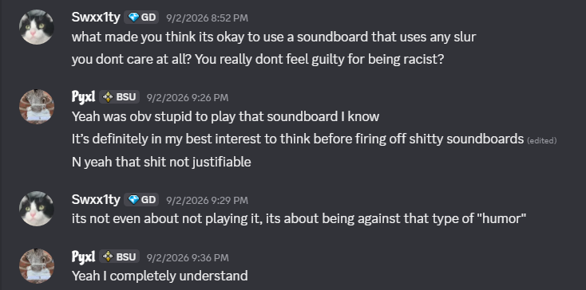

jambled_ 9/5/2026 9:04 PM
can black people say the n word

9:04 PM

just curious

9:04 PM

im assuming not

Big Hunky Daddy 9/5/2026 10:50 PM
i honestly would say no but it is really normalized for people to say it

10:51 PM

same like with lgbtq+ people saying the f slur

10:51 PM

i dont it matters on if youre part of the minority but i think its just not using those words that have hateful origins

10:51 PM

because it can still be used hatefully

Big Hunky Daddy 9/6/2026 4:39 PM
@Mariobye 👋

Mariobye 👋 9/6/2026 4:39 PM
what twindaddt

Big Hunky Daddy 9/6/2026 4:39 PM
ts guy actually under 13

4:39 PM

actual ban

Mariobi261 9/6/2026 9:04 PM
wait i can be here now

9:04 PM

yay

Mariobi261
wait i can be here now
Big Hunky Daddy 9/6/2026 9:04 PM

Big Hunky Daddy 9/7/2026 12:18 AM
@Mariobye 👋

12:18 AM

how old is mario black

Mariobye 👋 9/7/2026 12:18 AM
no idea

12:18 AM

13 or older

Big Hunky Daddy 9/7/2026 12:18 AM
r u sure?

12:18 AM

he sounds really young

12:18 AM

wait no

12:18 AM

i rmb him saying that hes like 12 or something

Mariobye 👋 9/7/2026 12:20 AM

Big Hunky Daddy 9/7/2026 12:21 AM
thats 2 people today that r under 13

Mariobye 👋 9/7/2026 12:21 AM
well

Big Hunky Daddy 9/7/2026 12:22 AM
@yopp :3 tryna steal my ban

Mariobye 👋 9/7/2026 12:22 AM
dont ban

Big Hunky Daddy 9/7/2026 12:22 AM
i know

Mariobye 👋 9/7/2026 12:22 AM
cause we could have been making assumptions

12:22 AM

after all we will never actually know

Big Hunky Daddy 9/7/2026 12:22 AM
he confessed </3

12:22 AM

n hero def was under 13

12:22 AM

my boy said jan 14 2011

12:24 AM

would've been 3 bans in the span of like a week

1

Big Hunky Daddy 9/7/2026 5:14 PM
@Mariobye 👋 buddy is falling for the rage bait

5:14 PM

its so obvious too

Mariobye 👋 9/7/2026 5:14 PM
who

Big Hunky Daddy 9/7/2026 5:14 PM
gav

Mariobye 👋 9/7/2026 5:14 PM
lol

Big Hunky Daddy 9/7/2026 9:40 PM
nah

9:40 PM

that was

9:40 PM

@Mariobye 👋

9:40 PM

@yopp :3

9:40 PM

@jambled_

9:40 PM

bro

jambled_ 9/7/2026 9:41 PM

Big Hunky Daddy 9/7/2026 9:41 PM
this guy just said a slur

9:41 PM

theres no way

Mariobye 👋 9/7/2026 9:41 PM
which one

9:41 PM

im not paying attention

Big Hunky Daddy 9/7/2026 9:41 PM
cheese

Mariobye 👋 9/7/2026 9:41 PM
cheese?

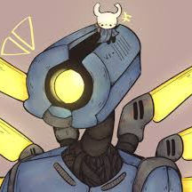

yopp :3 9/7/2026 9:41 PM
he said

9:41 PM

fa

9:41 PM

got

Mariobye 👋 9/7/2026 9:41 PM
ohh

9:41 PM

thats not hhow you even spell it

9:41 PM

gng

9:41 PM

but ok

yopp :3 9/7/2026 9:41 PM
i know

9:42 PM

i missed a g

Mariobye 👋 9/7/2026 9:42 PM
f****t

9:42 PM

thats

Big Hunky Daddy 9/7/2026 9:42 PM
feet

Mariobye 👋 9/7/2026 9:42 PM
just not it

Big Hunky Daddy 9/7/2026 9:42 PM
r we fr condoning this bro?

Mariobye 👋 9/7/2026 9:43 PM
what

9:43 PM

feet

9:43 PM

I love feet

9:43 PM

wtb it

Big Hunky Daddy 9/7/2026 9:43 PM
nah fr he said the f slur

Mariobye 👋 9/7/2026 9:43 PM
ok

9:43 PM

can I see daddys feet

Big Hunky Daddy 9/7/2026 9:43 PM
die

9:43 PM

like even a 1 day time out or something like that

Mariobye 👋 9/7/2026 9:43 PM


Big Hunky Daddy 9/7/2026 9:44 PM
u just told furaii that the moderation was getting better </3

1

Mariobye 👋 9/7/2026 9:44 PM
its all cause of you daddy

9:44 PM

:sob

9:44 PM

Big Hunky Daddy 9/7/2026 9:45 PM
so what do we do about cheese

jambled_ 9/23/2026 5:13 PM
when we doing the civilization endscreen?

jambled_ 9/23/2026 10:09 PM
tomorrow?

10:09 PM

idk brah

cat :3 10/16/2026 10:06 PM
@Mariobye 👋 y is swx1ty timed out

Mariobi261 10/16/2026 10:07 PM
idk

10:07 PM

i didnt time them out

cat :3 10/16/2026 10:07 PM
oh ok

Mariobi261
i didnt time them out
cat :3 10/16/2026 10:07 PM
can u check mod view rq to see who did

10:08 PM

oh wait nvm

Mariobye 👋 10/16/2026 10:16 PM
I did it

10:16 PM

because

10:16 PM

he pinged me

10:16 PM

in announcements

10:16 PM

and he is in call with me

10:16 PM

so why not

10:16 PM

and tyhis server

10:16 PM

is dead

10:16 PM

and no one

10:16 PM

checks it

10:16 PM

ever

10:16 PM

!!!

Mariobi261 10/16/2026 10:16 PM
can i get chudmin

10:16 PM

:3

cat :3 10/19/2026 11:09 AM
@Mariobye 👋 masquerade banned bcuz of this
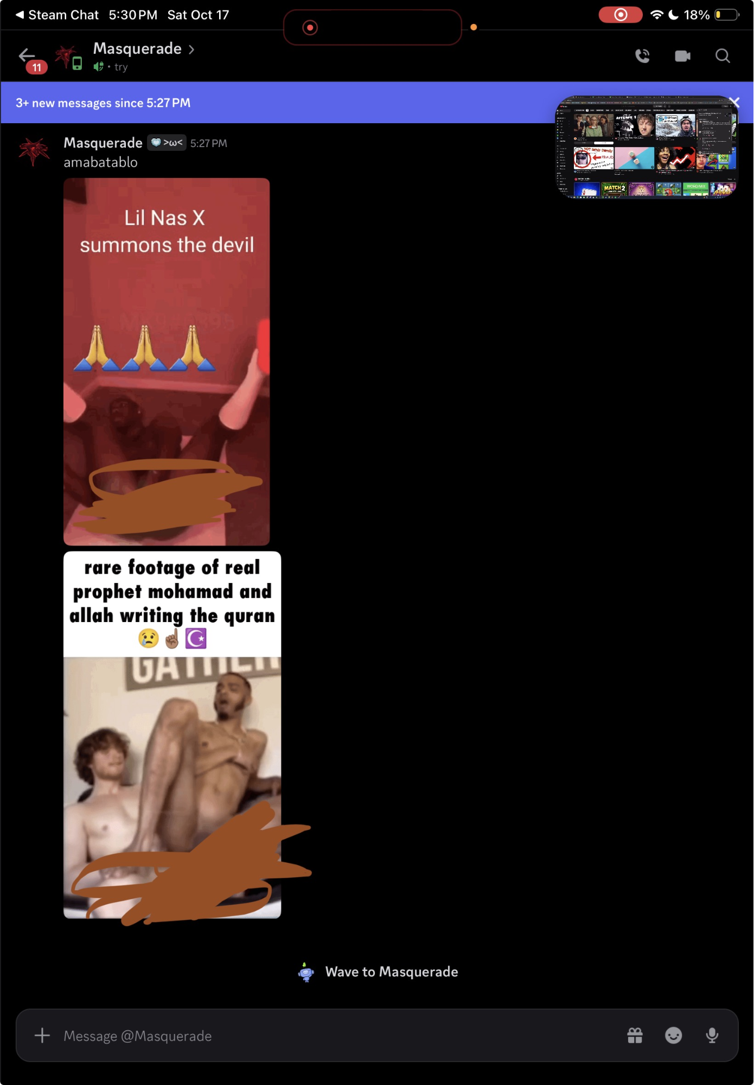

1

jambled_ 10/19/2026 4:10 PM
what the fuck

Mariobye 👋 10/19/2026 4:46 PM
Oh wow

Exported 255 message(s)
Timezone: UTC-6

